Thomas LERCHUNDI
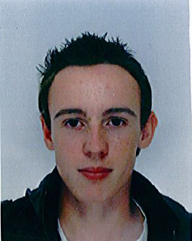
(19 years old) PLACEMENT

ABROAD
13 rue Beauséjour
33610 CESTAS
FRANCE
Tél : 06 45 29 15 05

lerchundi.thomas@gmail.com

Formation

… : 2nd year in University Institute of informatic

2013 : 1st year University Diploma of Technology of informatic validated
2012 : Bachelor of science with engineering science option

Computer knowledge: Programming languages C, C++, C#, Java, J2EE, SQL, Bash, HTML5, CSS3, PHP, XML, Javascript. Control of operating systems Windows 7 and Linux.
Control of Word, SolidWorks (modelisation), Access, MySQL , SQL Server, Visual Studio, Eclipse, Geany.
Knowledge

Professional experience

2013 : Sweeper, Service cleens of the city of Bordeaux

2013 : Order picker, SCAMER (Bègles)

2008 : Placement, Radiology center of Cestas

Center of interest

Cultural activities: Travel :England, Morocco, Spain, Senegal
guitar practice for 11 years (4 years in a band), knowledge of music theory
Sports : Badminton, football

